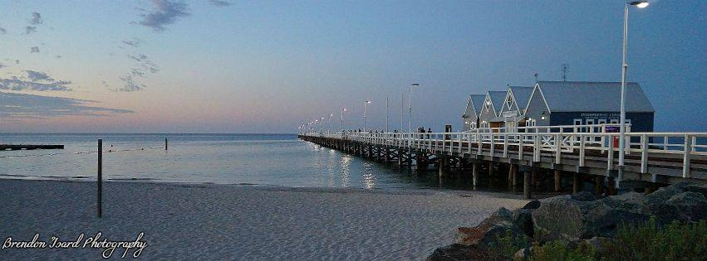
Geographe Bay Table Tennis Club

Venue: BUSSELTON YOUTH & COMMUNITY CENTRE
Cnr High St & Bussell Hwy, Busselton

Date: Saturday 30th June to Sunday 1st July 2018

*ENTRIES CLOSE ON FRIDAY 22nd June 2018

Send entry forms to Reg Peet, 1 Brown St, Busselton, 6280
or rpeet@bigpond.net.au

Phone enquiries Reg Peet (9752 4057) Yvonne Cleal (9751 2899 mob 0422 142 988)

Tournament Committee Neil Coy, Yvonne Cleal, David Cheshire, Ronald Faber, Matt Cheng,
Dudley Hamilton-Jones

Referees Reg Peet/Ronald Faber

ENTRY FORM

SURNAME | FIRST NAME
EMAIL | CLUB | DATE OF BIRTH
ADDRESS | PHONE
EVENTS ENTERED | TTWA rego no.

Date/Time | Event | Partner | Fee | Paid
Sun 1.30 pm | 1. Mens Open Singles |  | $10
Sun 1.30 pm | 2. Ladies Open Singles |  | $10
Sun 10.00 am | 3. Mens Open Doubles |  | $6 ea
Sun 10.00 am | 4. Ladies Open Doubles |  | $6 ea
Sun 11.30 am | 5. Mixed Open Doubles |  | $6 ea
Sat 12.00 pm | 6. U/13 Junior Singles (any gender) |  | $5
Sat 1.30 pm | 7. U/18 Junior Singles (any gender) |  | $5
Sat 10.30 am | 8. Special Singles Div 1 [ranking points under 1200] (any gender) |  | $7
Sat 8.30 am | 9. Special Doubles Div 1 [ranking points under 1200] (any gender) |  | $6 ea
Sat 11.00 am | 10. Special Singles Div 2 [ranking points under 800] (any gender) |  | $7
Sat 9.30 am | 11. Special Doubles Div 2 [ranking points under 800] (any gender) |  | $6 ea
Sat 1.30 pm | 12. O/40 Singles (any gender) |  | $7
Sat 12.30 pm | 13. O/50 Singles (any gender) |  | $7
Sat 2.00 pm | 14. O/60 Singles (any gender) |  | $7
Sat 12.30 pm | 15. O/70 Singles (any gender) |  | $7
Sat 4.00 pm | 16. Country Singles (any gender) |  | $7
Sat 3.00 pm | 17. Country Doubles (any gender) |  | $6 ea
Sun 9.00 am | 18. Drawn Doubles (any gender) |  | $6 ea
Sun 11.30 am | 19. Para Singles (AWD only) |  | $7
Sat 9.30 am | 20. Backyard Singles (for non TTWA members – see back page #13) |  | $7
 |  |  | TOTAL

ALL PAYMENTS MUST BE MADE DIRECTLY TO GEOGRAPHE BAY TABLE TENNIS CLUB

Please read all the conditions on the final page of this entry form. Please indicate that you are prepared to abide by all the condition by signing in the box below or (if you are entering on-line) type in your acceptance in the box below.
I have read the conditions of page 4 and agree to abide by them  Signature |  | Date

Select method of payment and tick the right hand box below
Cheques made payable to Geographe Bay Table Tennis Club
Electronic Bank Transfer to GBTTC, BSB (066 508) account (1026 8513)
Please reference your surname.
Please indicate the number who will be attending the Dinner, 7.30 pm Saturday, at the Ship Inn Hotel. Individuals will pay as the meal is ordered. Average main meals are approx. $20 - $40.

OUR CHAMPIONSHIP SUPPORTERS

SATURDAY EVENING DINNER at THE SHIP INN
The Championship dinner will be held at the Ship Inn on Bussell Hwy, near to the Table Tennis Centre.
Saturday 30th June, starting at 7.30pm.
Payments will be made individually as you order.
Please indicate if you would like to attend on your entry form. We will need to know numbers by the close of entries.

ACCOMODATION at BUSSELTON MOTEL ph (08) 9752 1544
Busselton Motel (formerly Amaroo) is offering a special discount to competitors in our Championship. Mention our Club’s name and you will get a standard double room for $85. The Motel is only 150 m from the table tennis hall and 350m from the Ship Inn.

BUSSELTON CITY
Busselton City Council has always been a great supporter of our Club with equipment grants and hall hire discounts for our tournaments.

CLAIRAULT
The wines that Geographe Bay Table Tennis Club are using for trophies this year come from the superior winery CLAIRAULT.

TEA , COFFEE and FOOD
Help-yourself Tea and coffee will be available in the kitchen for $1
Coffee and food is available at Rise and Co, 50 m across the road from the Centre

PROPOSED SCHEDULE OF PLAY

Players are required to register with Officials 10 minutes prior to their event

 | SATURDAY 30th JUNE |  |  | SUNDAY 1st July
8.30 am | Special Div 1 Doubles |  | 9.00 am | Drawn Doubles
9.00 am |  |  | 10.00 am | Mens Open Doubles
9.30 am | Special Div 2 Doubles  Backyard Singles |  |  | Ladies Open Doubles
10.00 am |  |  | 11.30 am | Para Singles
10.30 am | Special Div 1 Singles |  |  | Mixed Open Doubles
11.00 am | Special Div 2 Singles |  | 1.30 pm | Ladies Open Singles
11.30 am |  |  |  | Mens Open Singles
12.00 pm | U/13 Juniors
12.30 pm | O/50 Singles |  | 3.00 pm | FINALS
 | O/70 Singles |  |  | 1. Mens semi singles (a)
1.30 pm | O/40 Singles U/18 Juniors |  |  | 2. Mens semi singles (b)
2.00 pm | O/60 Singles |  |  | 3. Mixed Open Doubles
2.30 pm |  |  |  | 4. Mens Open Doubles
3.00 pm | Country Doubles |  |  | 5. Ladies Open Singles
4.00 pm | Country Singles |  |  | 6. Mens Open Singles

Players should be aware that these times may vary slightly
depending on the number of entries in any event.

Please check any revised schedule when you arrive at the Centre

CHAMPIONSHIP CONDITIONS

1. A separate entry form must be used for each competitor.
Entry fee MUST accompany each entry.

2. Completed entry forms should be emailed to rpeet@bigpond.net.au
or via postal mail addressed to R Peet, 1 Brown St, Busselton, 6280.
* Entries close on Friday 22nd June 2018*

3. The Championship will be played under TTA conditions.

4. DHS 3 star 40 + plastic balls will be used.

5. Dress regulations suitable for white ball play will be adhered to.

6. Each match will be controlled by an umpire whose decisions will be final on point of fact.

7. The Referee’s decision will be final on point of law.

8. The Tournament Committee reserves the right to refuse entries, to cancel or amalgamate any event, or make other small changes due to entry numbers or unexpected circumstances.

9. Competitors MUST be a registered member of TTWA or an affiliated club/association.
Exceptions occur for entries in the Backyard Singles (20) and the two Junior events (6,7)

10. Over-age events are open to persons who will have attained that age group by the end of 2018. Players entering these events may play in their own age group and one other over-age group of a lesser age.

11. Under- age events are open to persons who will be below that age group at the begining of 2018.

12. Players may enter a country event (Events 16 - 17) providing they do not live overseas, interstate, or within a 60km radius of Perth GPO.

13. Special Events
Special events Division 1 are open to all players with Ranking Points below 1200, or who the Organising Committee believes is below that standard.
Special events Division 2 are open to all players with Ranking Points below 800, or who the Organising Committee believes is below that standard.
Backyard Singles are open to players who are not members of TTWA and have no Central Ranking.

14. (a) Events 1 - 2 will be best of seven (7) games.
(b) Round Robin events and the Drawn Doubles will be best of three (3) games.
(c) Other matches will be the best of five (5) games.

15. Players will be required to umpire during the Championships.

16. Partners for Event 18 (Drawn Doubles) will be allocated by the Organising Committee.

17. Players must report to the Official Table 10 minutes before their first event of the day is scheduled.

*Players absent when called upon may be disqualified.

